**Software Engineering Tools Lab**

**Assignment No-1**

**Module 1- Introduction to FOSS**

**PRN : 2020BTECS00079**

**Batch : T7**

**1 Differentiate in between free software, Open source software and proprietary software with respect to its properties.**

Free software refers to the software that is available free of cost and can be used, copied, modified, and distributed without any restriction. The focus of free software is on freedom of use, not necessarily the price.

Open source software refers to the software that has its source code available to the public, allowing anyone to inspect, modify, and distribute the code. The focus of open source is on transparency and collaboration in the development process.

Proprietary software, also known as closed-source software, is software that is owned by an individual or a company and is not freely available for use, modification, or distribution. The source code is not disclosed to the public and is kept proprietary. The focus of proprietary software is on the commercial exploitation of the product.

With respect to their properties, the main differences between these types of software are:

1. Availability: Free software and open source software are freely available to the public, while proprietary software is not.
2. Source code: Open source software and free software come with their source code, while proprietary software does not.
3. Modification: Free software and open source software can be modified by anyone, while proprietary software cannot.
4. Distribution: Free software and open source software can be distributed freely, while proprietary software can only be distributed with the permission of the owner.
5. Support: Free software and open source software have a large community of users who provide support, while proprietary software has limited support from its developers.
6. Security: Open source software is considered more secure as many people can review the code, while proprietary software is considered less secure as only a few individuals have access to the code.

**2.Enlist some examples along with its purpose and properties (at least 10) of FOSS and proprietary software with respect to database**

1. MySQL: A popular, relational database management system used for web applications and data warehousing. It is free and open-source.
2. PostgreSQL: An advanced, open-source relational database management system that supports complex data types, indexing, and transactions.
3. MongoDB: A NoSQL database management system that is designed for scalability and ease of use. It is open-source.
4. Cassandra: A highly scalable, distributed database management system designed for handling large amounts of data across multiple nodes. It is open-source.
5. MariaDB: A community-driven, open-source relational database management system that is a fork of MySQL.
6. Redis: An open-source, in-memory data store that is often used for caching, pub/sub messaging, and job queues.
7. Firebird: A relational database management system that is designed for fast performance and small footprint. It is open-source.
8. CouchDB: A NoSQL database management system that uses a document-oriented data model. It is open-source.
9. RethinkDB: A document-oriented database management system that provides real-time push notifications. It is open-source.
10. SQLite: A compact, lightweight, serverless relational database management system that is suitable for small and embedded applications. It is open-source.

**3.** **Enlist some examples of free open source exam software for online assessment.**

**TCExam**

**Moodle**

**Papershala**

**FlexiQuiz**

**Eklavvya**

**4.** **Demonstrate any one exam software which is open source and freely available.**

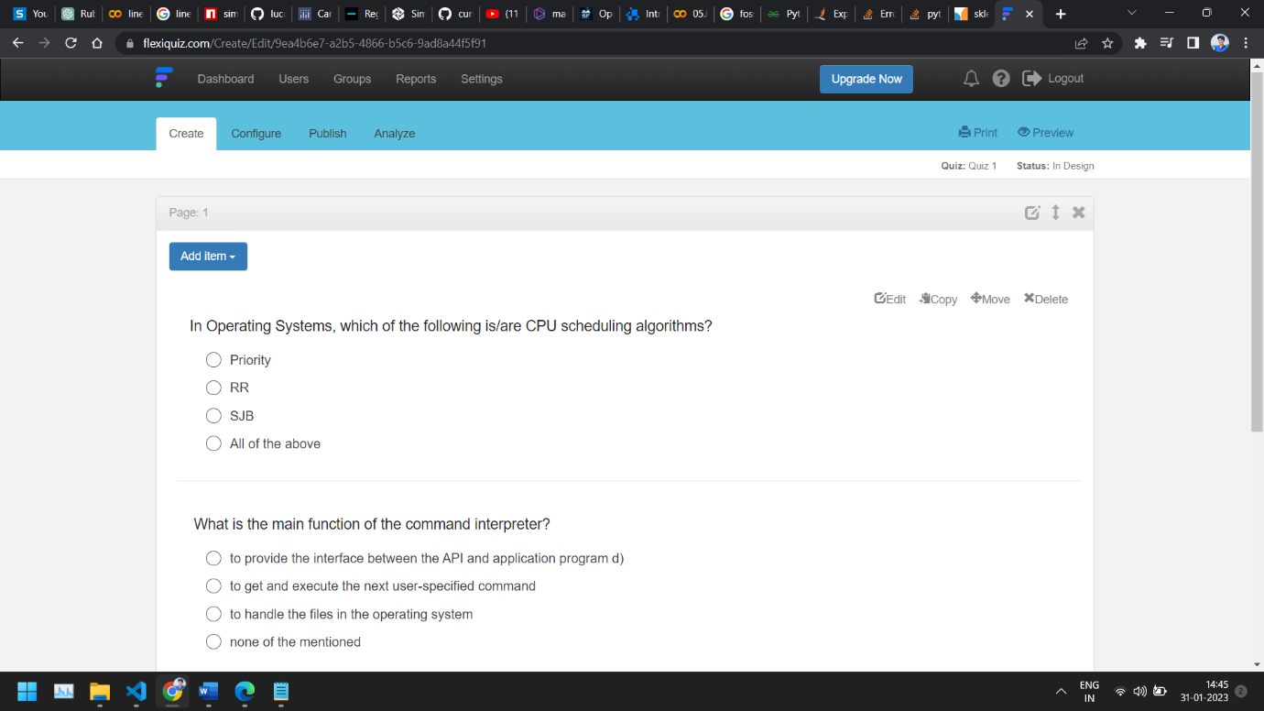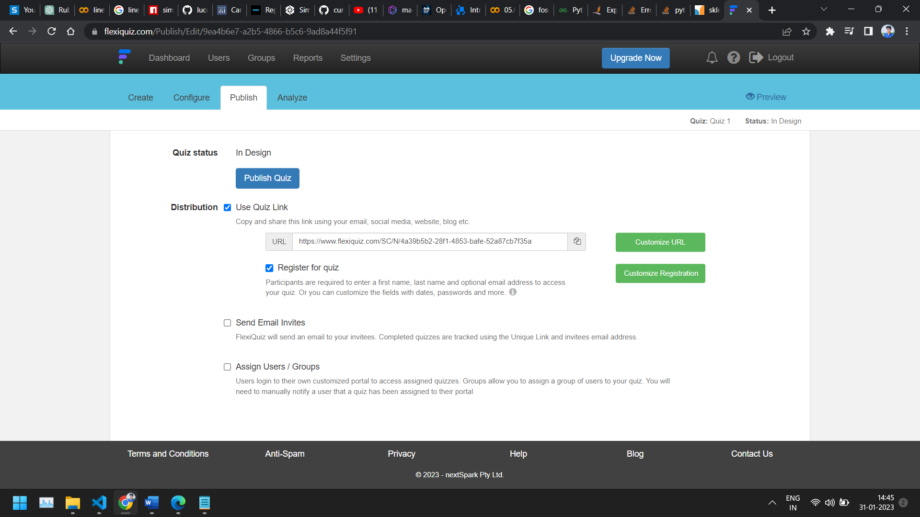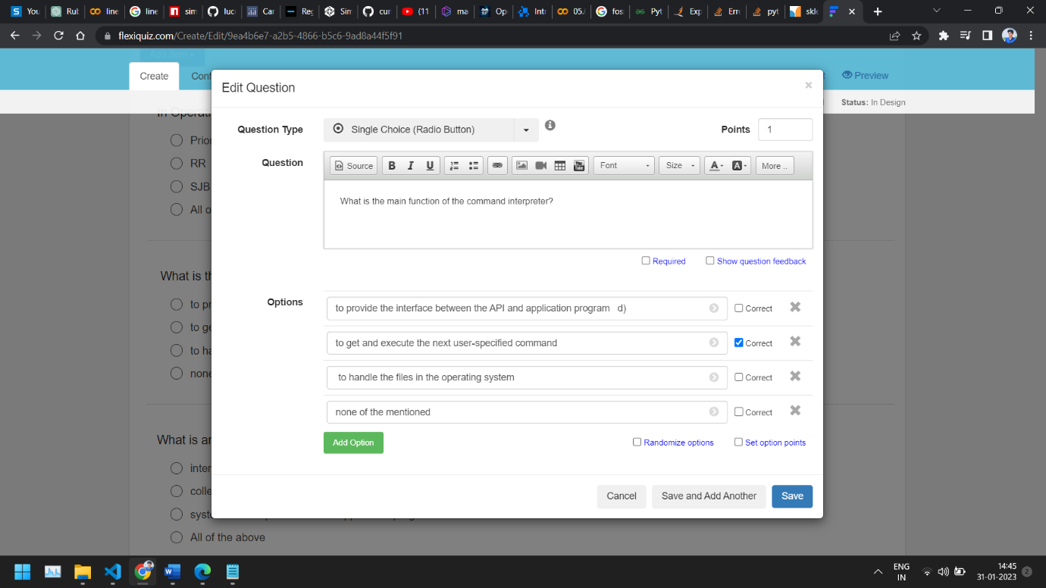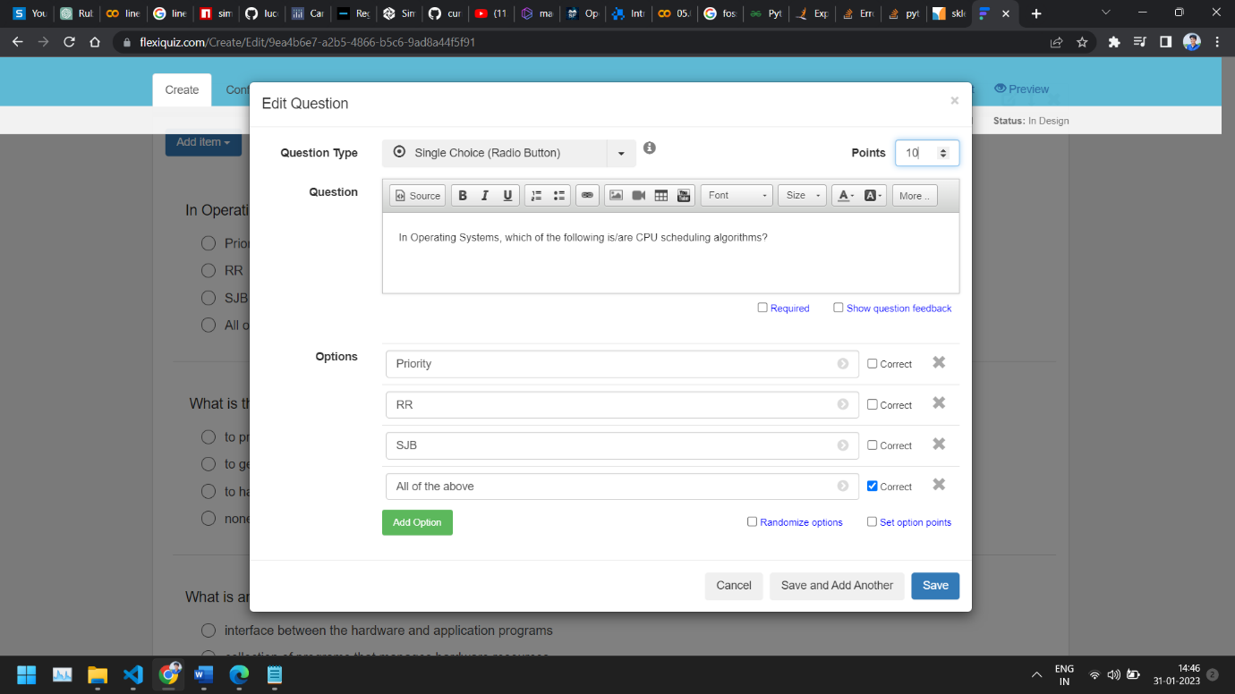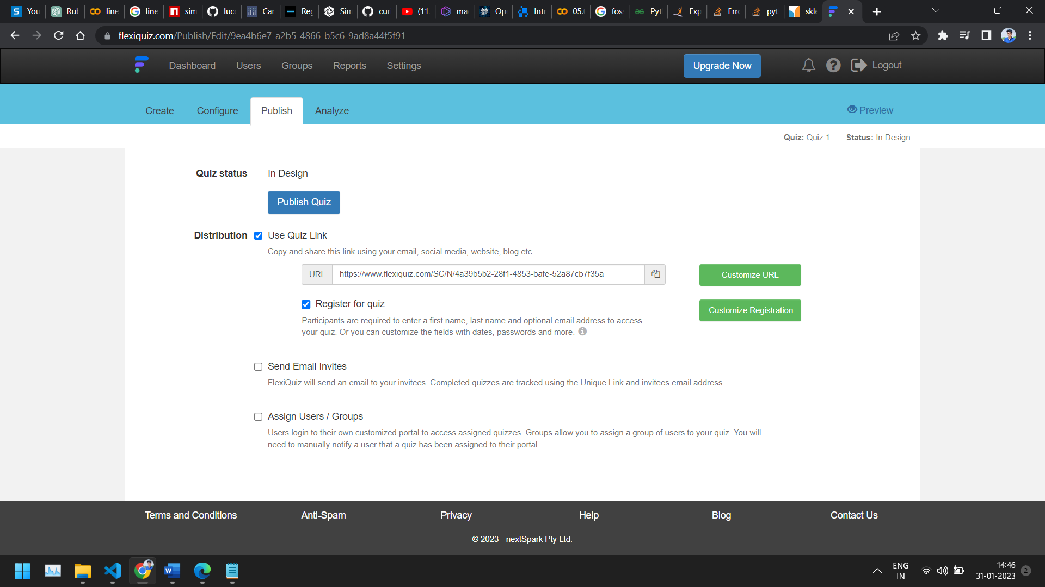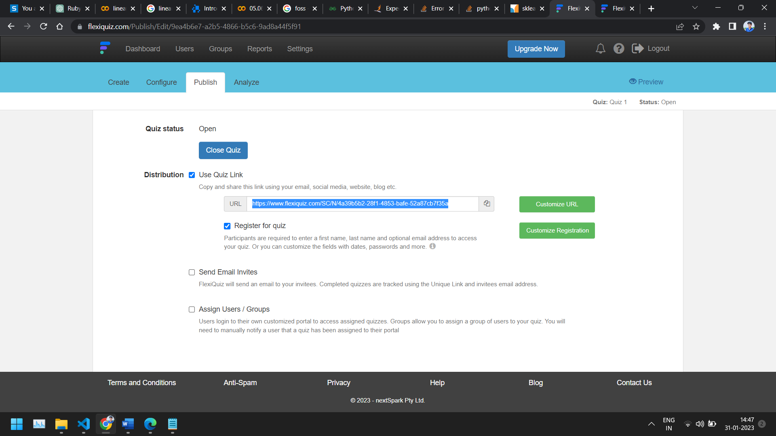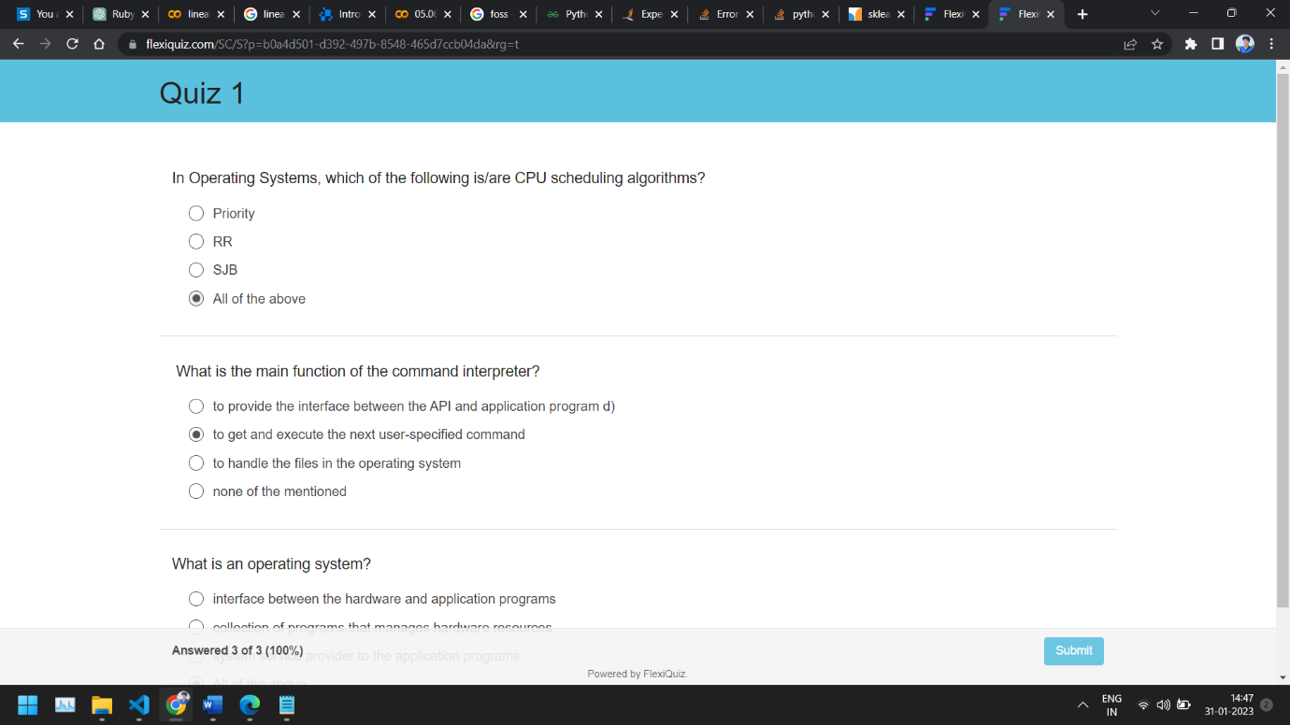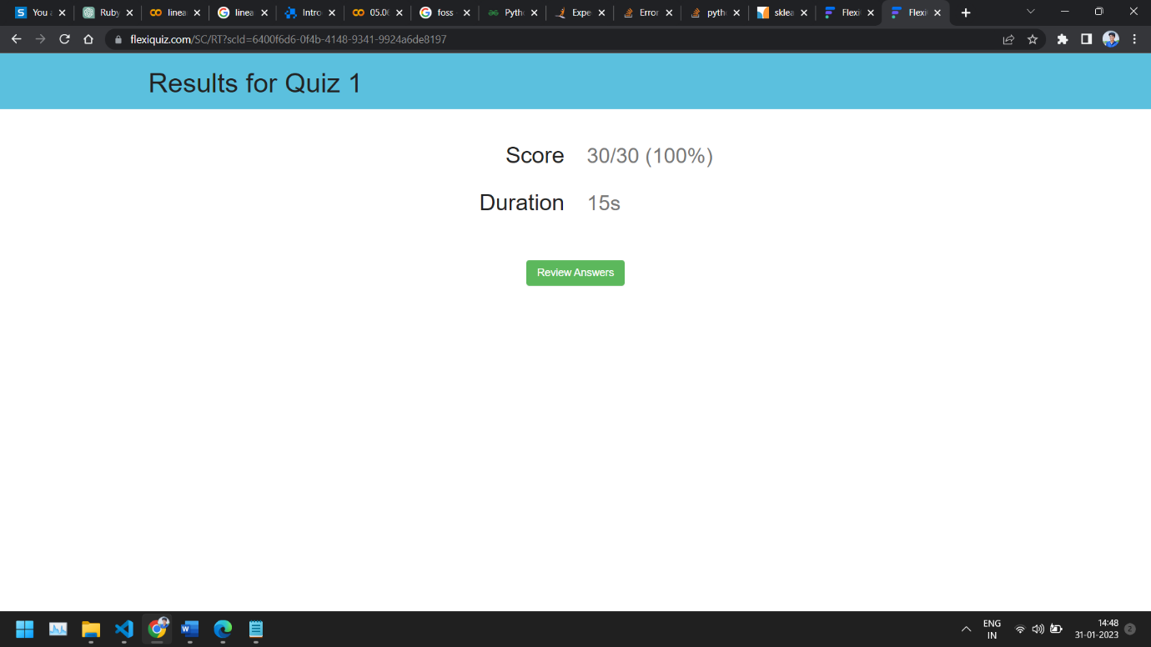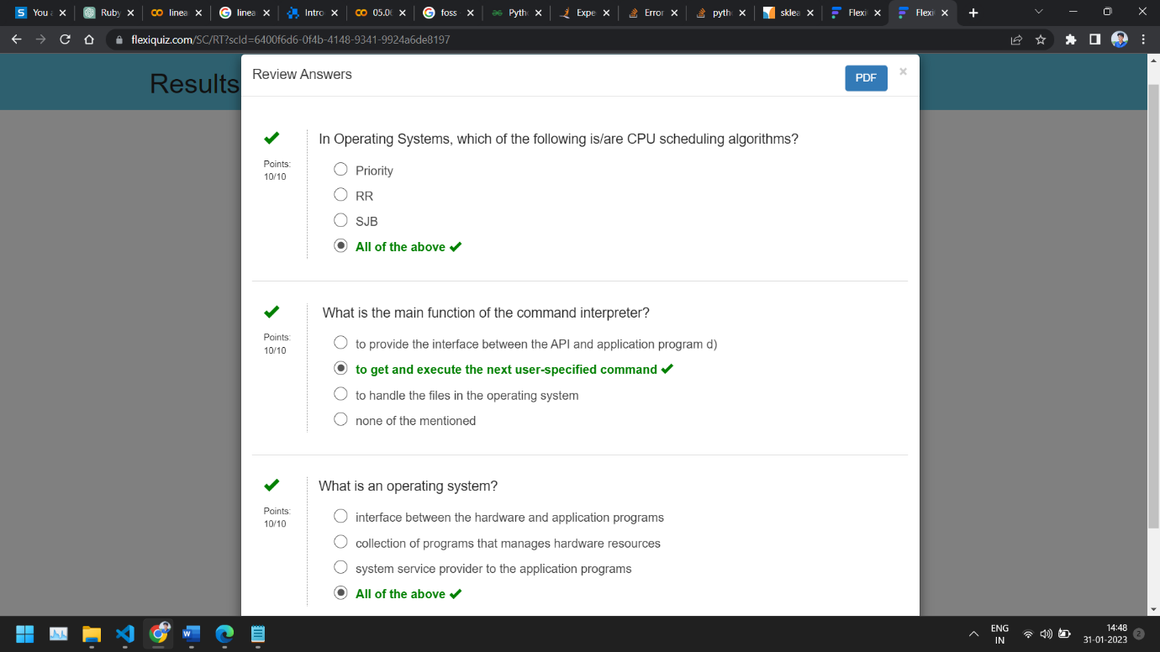

**5.Demonstrate FOSS software related to database**

**MongoDB**

MongoDB is a NoSQL database that stores data in a flexible, JSON-like format called BSON.

1. Purpose: MongoDB is used to store large amounts of unstructured and semi-structured data, such as documents, images, and videos.

* Document-Oriented: MongoDB stores data in a document-oriented format, which allows for greater flexibility in how data is stored and retrieved.
* Scalability: MongoDB is designed for horizontal scalability, meaning that it can easily handle large amounts of data and a high number of concurrent users.
* High Performance: MongoDB provides fast, real-time access to data through its use of an in-memory storage engine and indexing.
* NoSQL: MongoDB is a NoSQL database, meaning it does not use traditional SQL-style table structures.
* Easy to Use: MongoDB is easy to learn and use, with a simple and intuitive query language that is similar to JavaScript.
* Replication: MongoDB supports automatic, real-time replication of data, providing high availability and reliability.
* Sharding: MongoDB supports sharding, which allows data to be split across multiple servers to support large data volumes and high traffic loads.

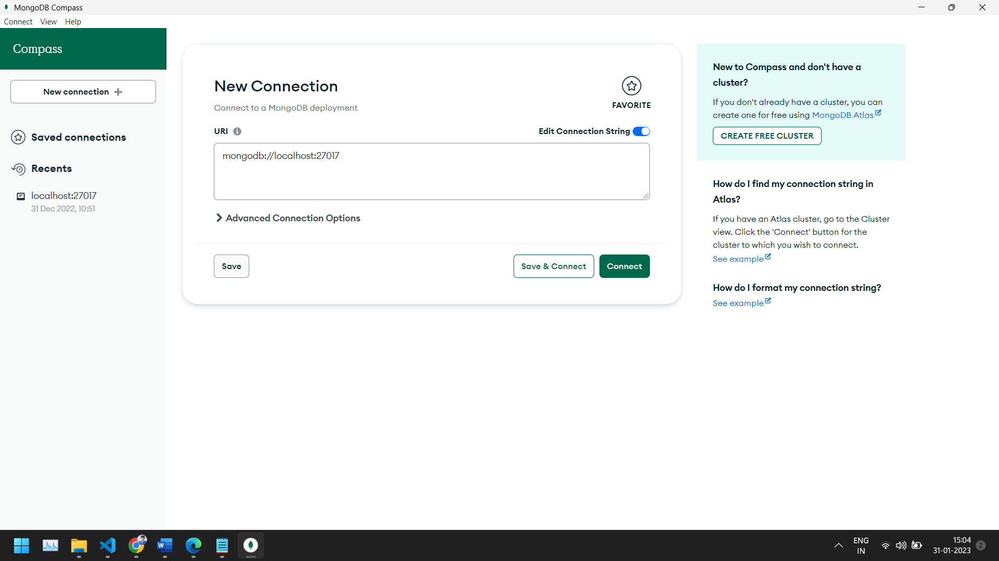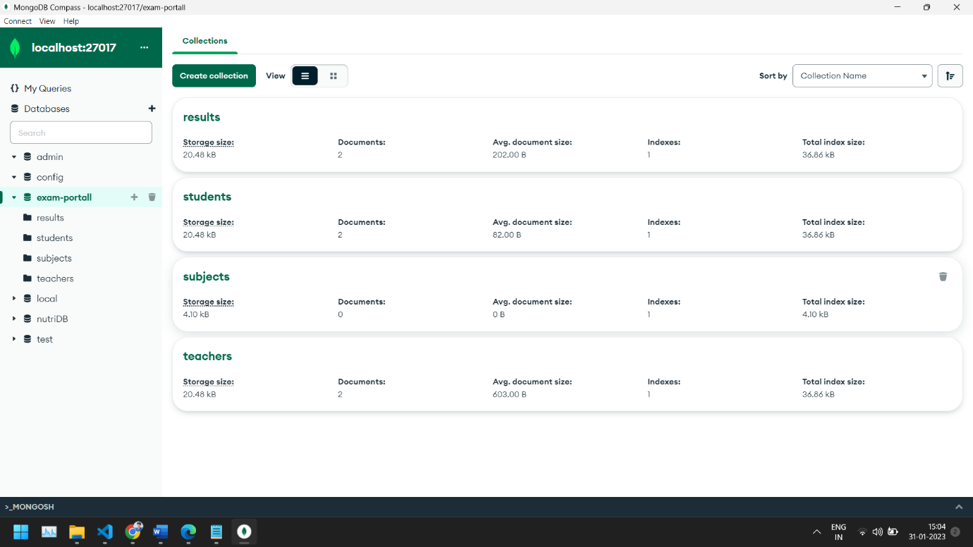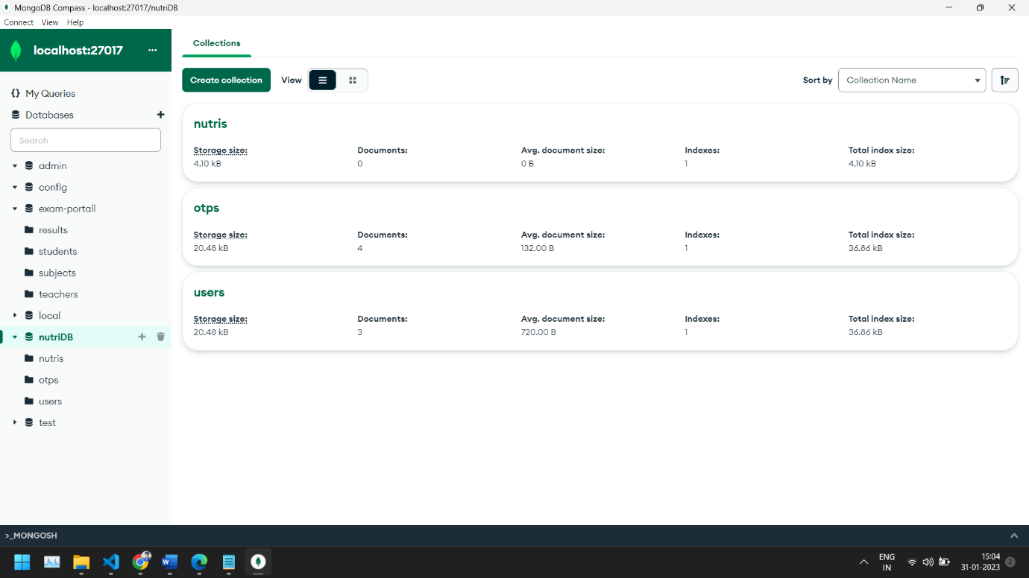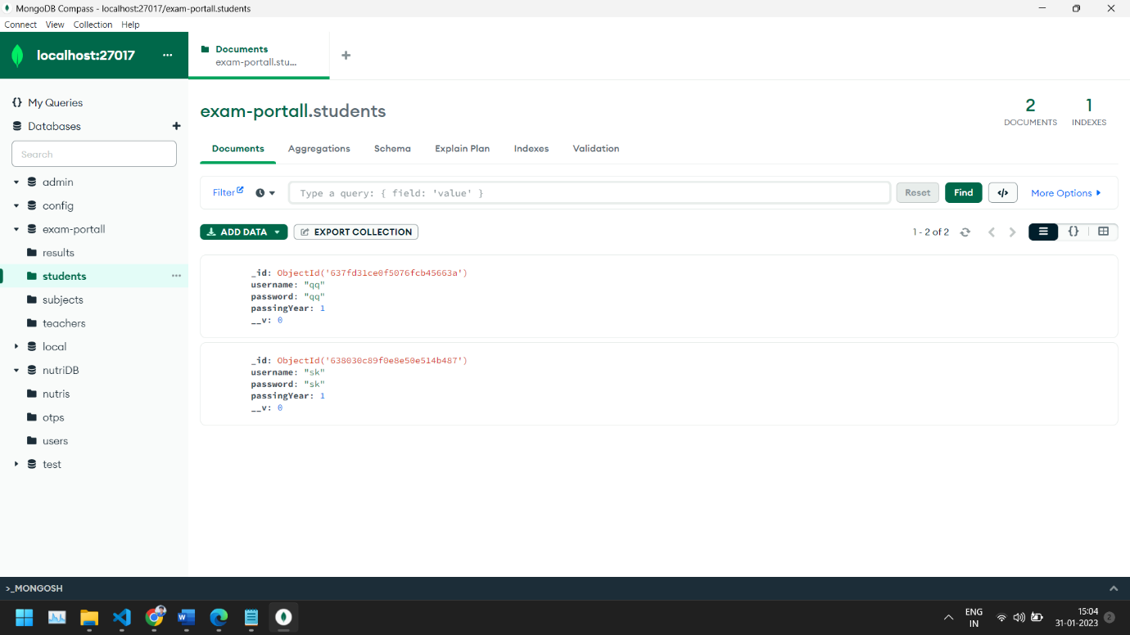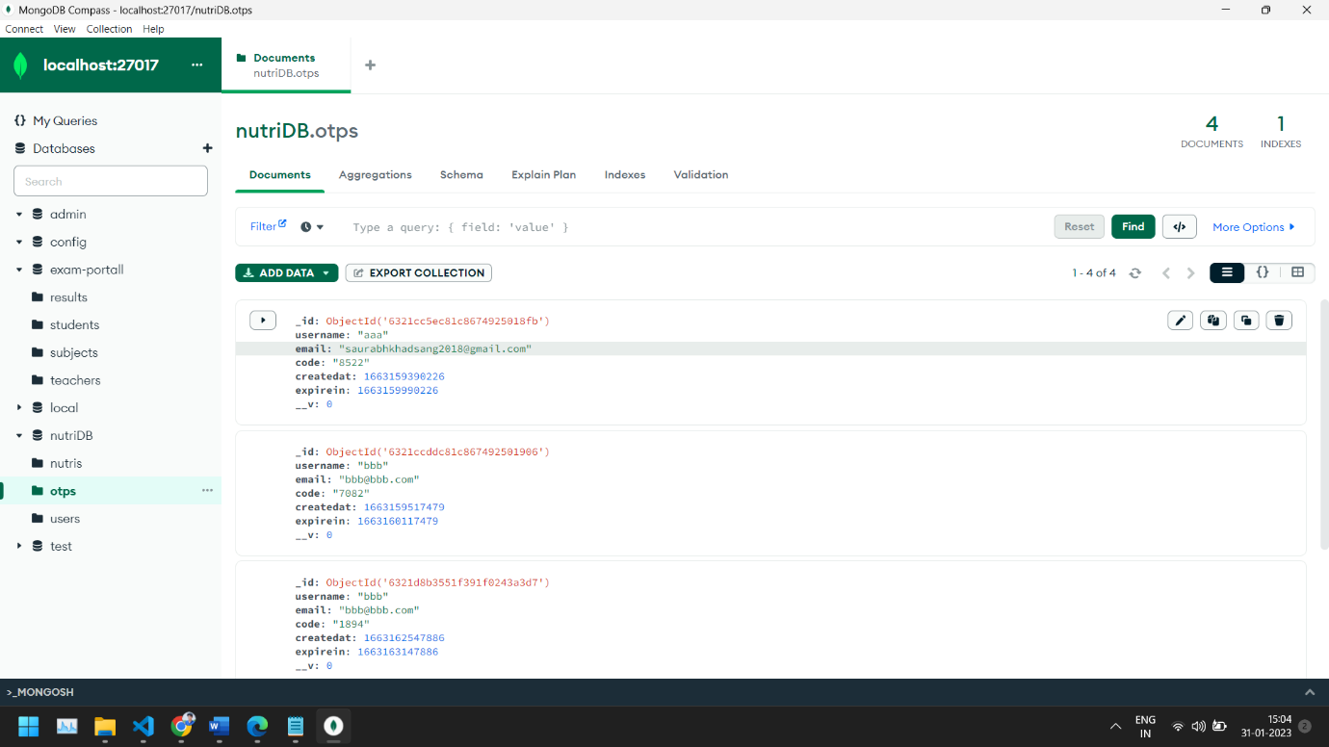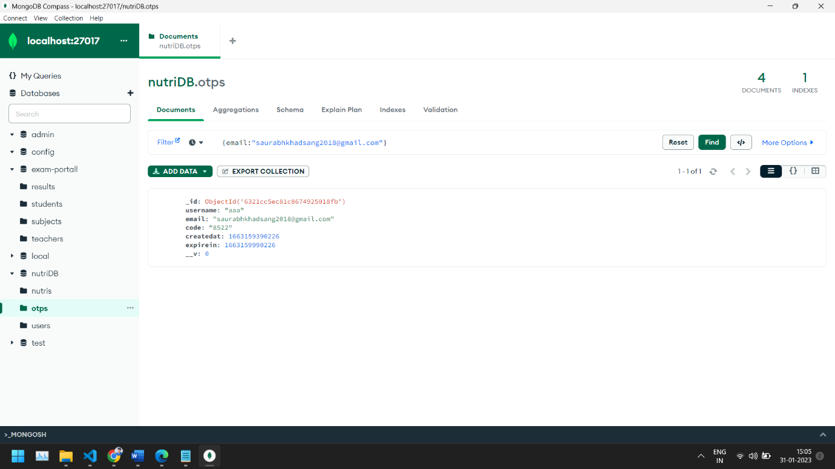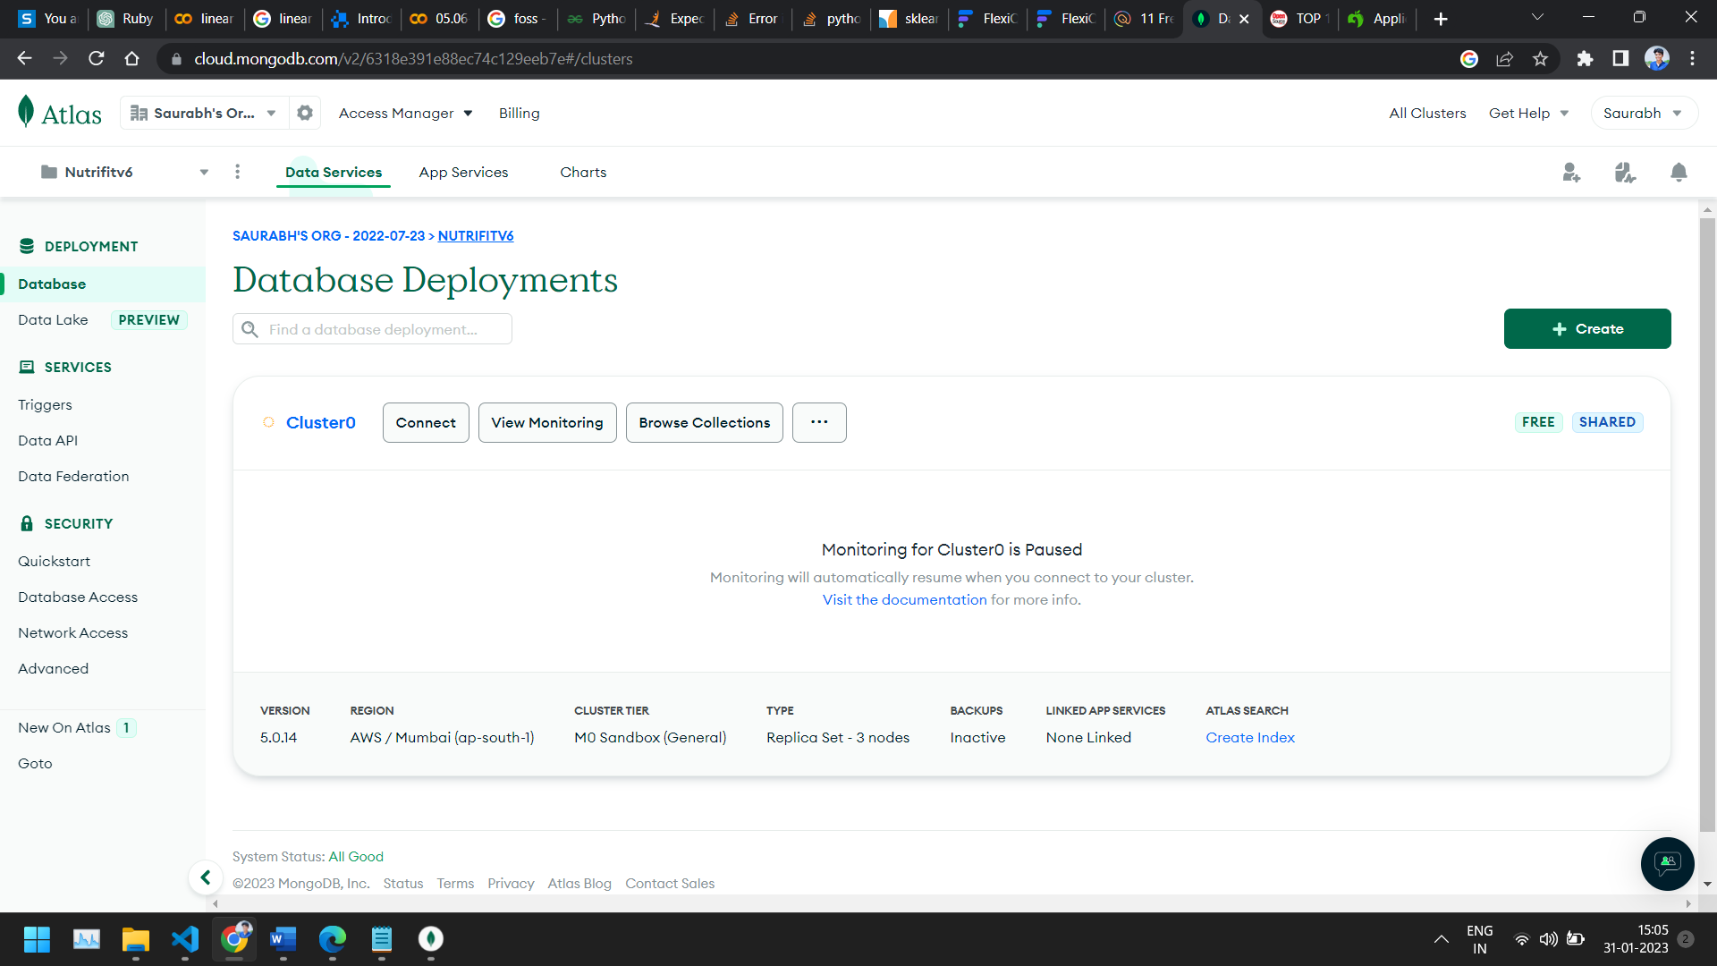

**6.** **How does the Exam software work?**

FlexiQuiz is a cloud-based exam software that allows users to create, deliver, and manage online assessments. It provides features such as question creation, customizable templates, automatic grading, real-time analytics, and secure data management.

Here's how it works:

1. Creating the Exam: Users can create an exam by selecting questions from a question bank or by creating custom questions.
2. Delivery: The exam can be delivered to participants through a unique URL. The software provides options for timed exams, self-paced exams, and proctored exams.
3. Grading and Analysis: The software automatically grades the exams and provides real-time analytics such as individual and overall performance, question-wise analysis, and more.
4. Data Management: The software securely stores the exam data and provides access to it through a dashboard.

Overall, the FlexiQuiz Exam software provides a streamlined solution for delivering and managing online exams, making it easy for educators, trainers, and organizations to assess their students, employees, or members.